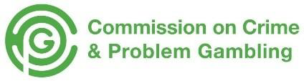
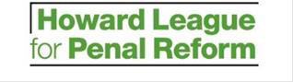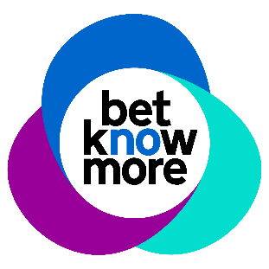

The Howard League’s Commission on Crime and Problem Gambling is undertaking two research projects about crime and gambling-related harms. One focuses on the lived experiences of women, and the second on the lived experiences of people from ethnic minority communities. The overarching goal of the research is to develop a knowledge base within the criminal justice system that recognises women’s and ethnic minorities’ experiences of gambling-related harms and their needs, thus lowering the potential for criminal justice interventions in the future.

These are peer research projects, which means that women and people from ethnic minority communities are not only involved as research participants, sharing their thoughts and experiences, but also as researchers, helping shape and implement the projects.

This application form is a chance for you to tell us about you, some of your experiences and why you are interested in taking part in this research as a peer researcher. Please answer the questions to the best of your ability.

Peer researcher application form

Please tick which research study you would like to apply to:

Women, crime and gambling-related harms

Ethnic minority communities, crime and gambling-related harms

Your details

Name:

Address:

Postcode:

Phone:

Email:

Supporting statement
Please tell us why you applied for this role. Please tell us about any life, work, or educational experience that you think is relevant to this role. Consider what skills, knowledge, and expertise you have, but also include what you hope to gain from becoming a peer researcher on this project.

Understanding gambling-related harms and crime
How, and in what ways, do you think gambling can be problematic? What gambling-related harms do you think are most important to consider and why?

Gambling can lead to criminal behaviour but the link between gambling and crime is not very well understood. In your opinion how can gambling and crime be linked to one another?

Optional image upload
Please use the next box to upload an image that captures what gambling means to you. This could be a photograph or an image from the internet. Alternatively you could draw something and upload a photo of what you have drawn. Please add a few lines to explain why you selected the image that you did.

Interview arrangements and availability
If you have a disability, please tell us if there are any reasonable adjustments we can make to help you in your application or with our recruitment process.

Are there any dates when you will not be available for interview?

The team of peer researchers will begin working on the project in January 2022 and the research will be completed by October 2022. It is anticipated that each of the peer researchers will dedicate between 50 and 75 hours to the project, averaging at about 8–10 hours per month for the first six months, when peer researchers will be most heavily involved.

Are there any days of the week or significant dates that you would be unavailable?

Declaration
I confirm that to the best of my knowledge the information I have provided on this form is correct and I accept that providing deliberately false information could result in termination of the peer researcher role.

Name:

Signature:

Date:

Submission

Please send your application by 12 pm (noon) on Friday 10 December to:

liz@betknowmoreuk.org

